Velostrata Migration to GCP

Creating the Velostrata Manager in GCP

VPN Tunnel in GCP

Velostrata will communicate with vSphere through a private connection; you need to create a VPN tunnel in GCP that connects to the VMWare data center.



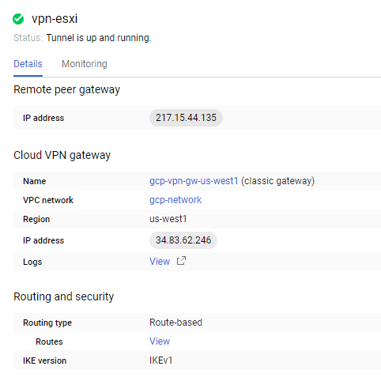

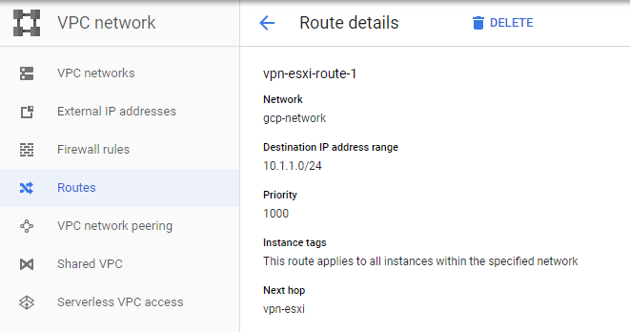

vSphere Configuration

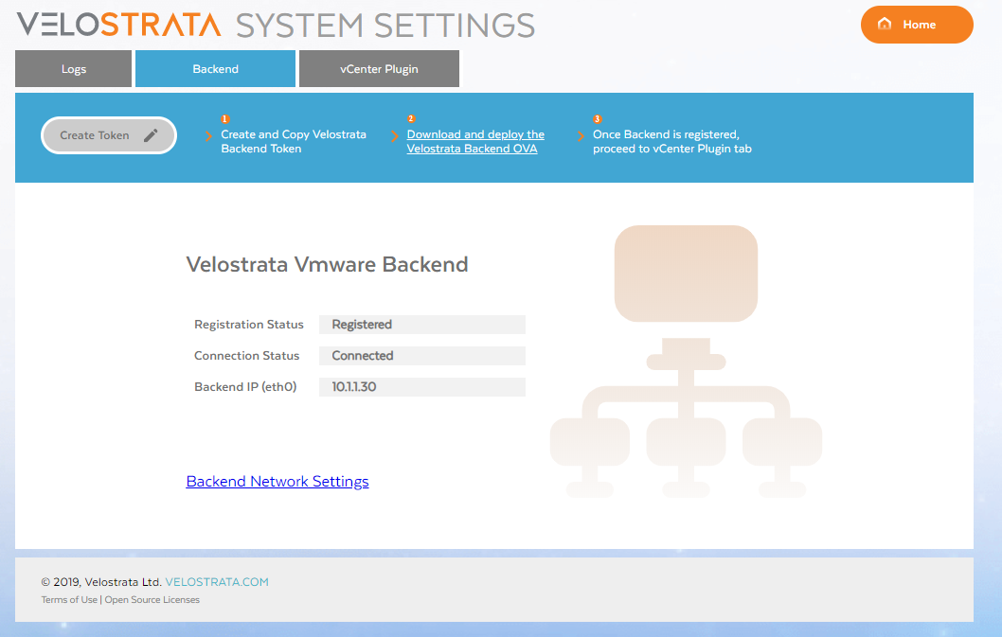

vCenter Plugin Installation

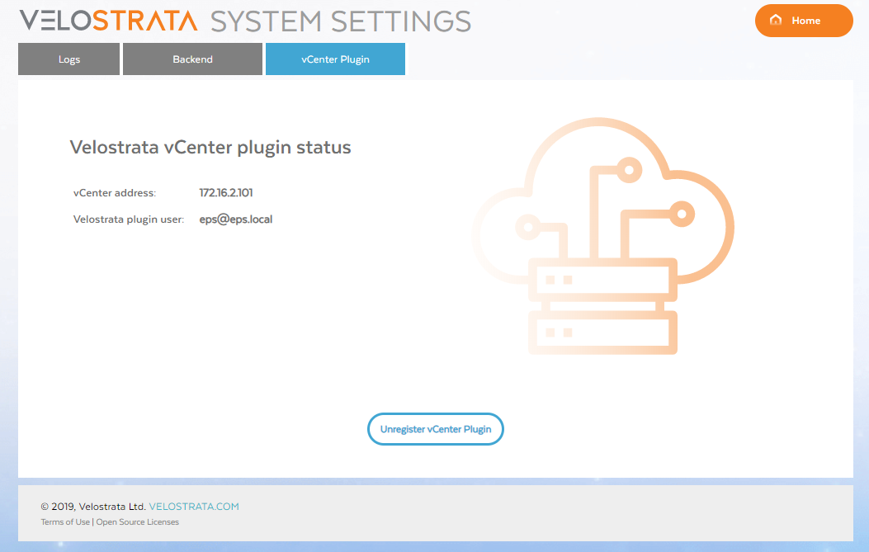

Configure Cloud Extension

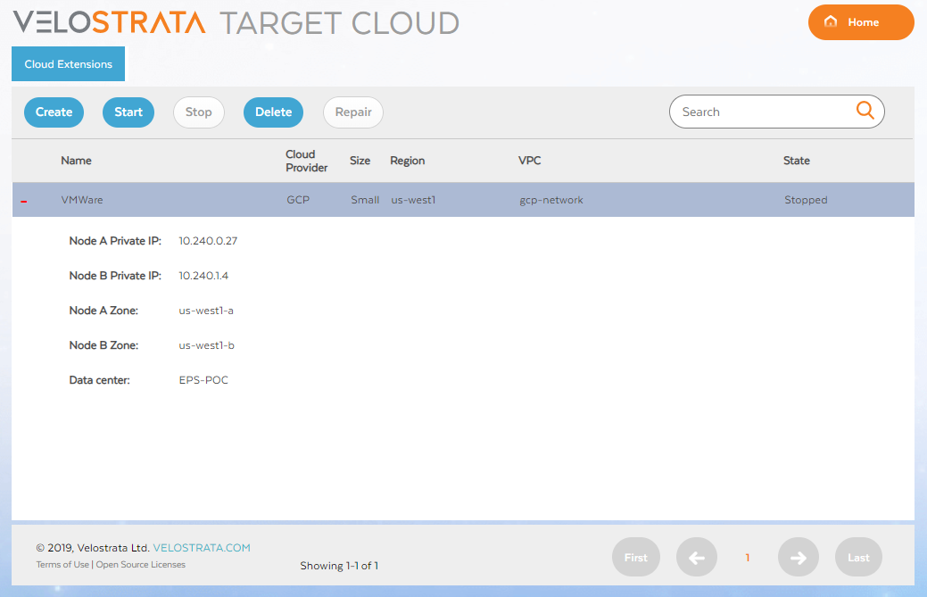

These are the VMs that Velostrata will create in GCP for the waves migration, it will always create two, and the size of the VMs depends if the configuration is “Large” or “Small”

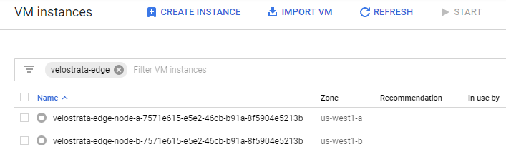

Generate the Runbook

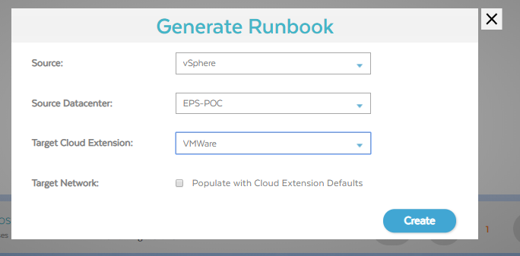

Modify the CSV to include the instance type, the GCP project, and the migration group.



Create a new Wave by uploading the runbook:

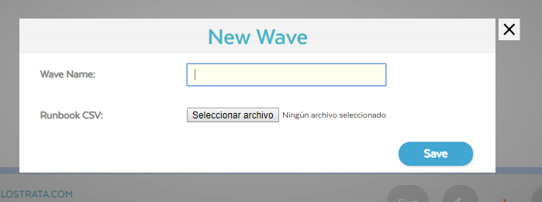

Validate the runbook:

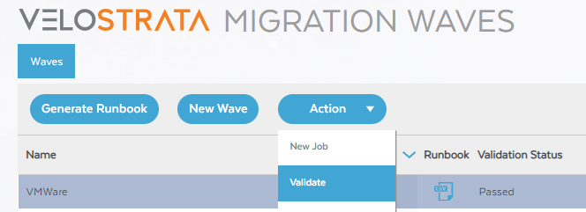

Create a new Job:

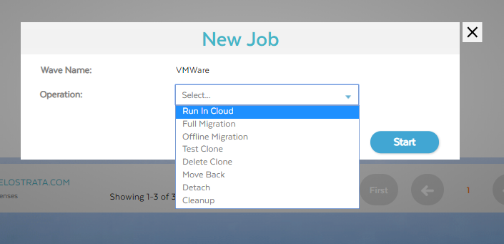

You can monitor the migration status:

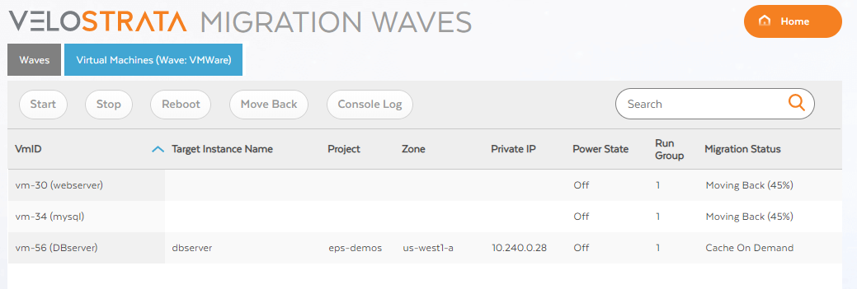

And you can see the migration logs in more detail:

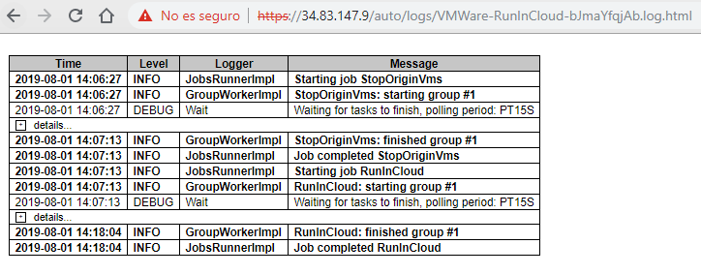

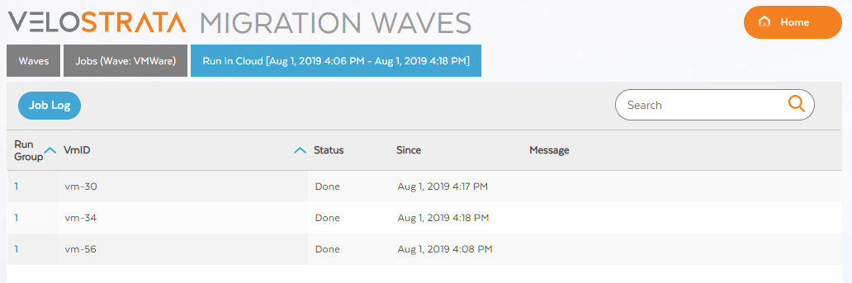

Troubleshooting

* Make sure you have enough quota for storage in the GCP project
* Make sure the subnets can communicate with each other
* You can always confirm what’s happening using [Stackdriver logs](https://cloud.google.com/velostrata/docs/how-to/monitoring/viewing-stackdriver-logs)
* You can also see the activities page in GCP for any other error as in the quota when Velostrata tries to create a new VM or something similar